**Docker day4 task**

**1.Installing docker and docker compose  
  
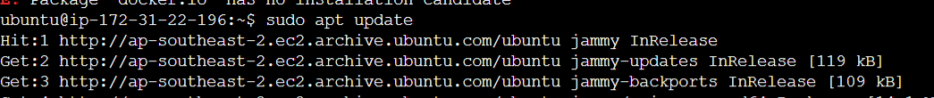**



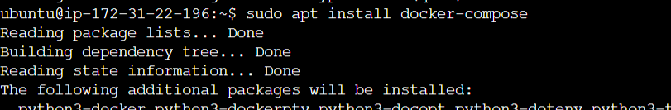

**2.creating docker file.**



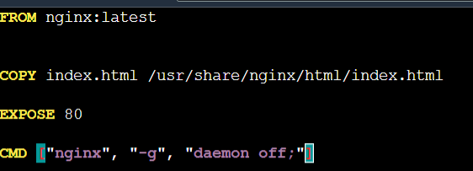

**3.Creating html file**



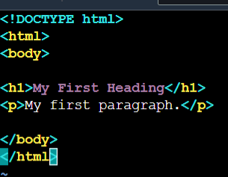

**4.creating docker compose**



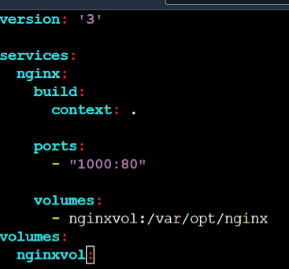

**5.running the docker compose**

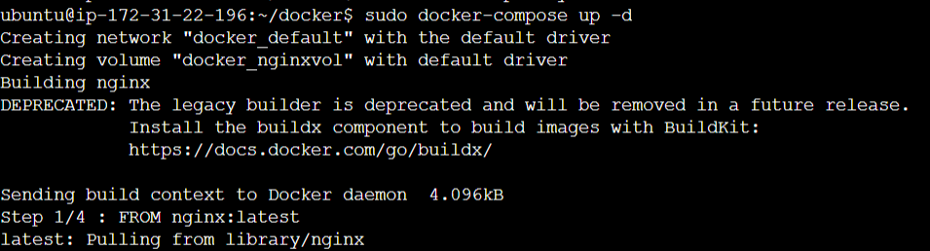

**6. list of Volumes**

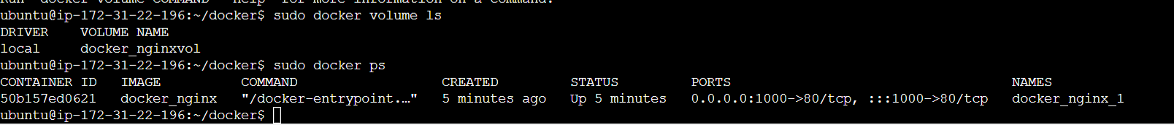

**7. containers**



**8.Pushing docker image to docker hub  
**